Global Expansion of Ramalingam Foods

Assignment Taken
Develop a Hiring & Incentive strategy for Human resources working on international expansion to enable a speedy growth.

Case Understanding

Ramalingam Foods is a fast-food restaurant, they introduced a Idli-Dosa batter powder which became an instant hit. The management has noticed an increase in demand for the product foreign countries. So, they are now looking for international expansion. As a HR manager, 1) There is a need to change the organisational policy because of global expansion. 2) Understanding the demographics of the targeted region is also necessary to hire the required manpower. 3) Understanding the increased complexity and cultural differences amongst the countries. 4) Address the need for Coordination. 5) Develop a mechanism for transfer of knowledge and innovation.

BCS Solution Summary

Organisational structure needs to be changed to a Global Matrix structure. The regions for expansion that is suggested is Southeast Asian countries. While building global capabilities, their needs to be an awareness about the product among the locals. One of the important things for global expansion and sustainability of a company would be proper training to see directed and fast growth for the company. Incentives are not only in terms of monetary basis, so the incentives and benefits have been planned for all low level, middle level and high-level management reasonably. The newly recruited employees of the new foreign location should be instructed and made motivated to understand about the taste and preferences of the local population of the country. The employees should consult the marketing department in understanding the taste and preferences of the local department. Also, the company should look to hire more local people of the new country. The management of Ramalingam Foods should be in liaison with both HR department and the Government of each country to understand and gain knowledge about the salary structure, and also coordinate with the finance department regarding the cost of Hiring and Incentive strategy to be undertaken.

Solution
Ramalingam foods has a variety of food products ranging from north Indian instant mixes to south Indian instant mixes, after digging deeper into the different demographics and population statistics of Indian Population, we suggest that entering southeast Asian market would be fruitful. Ramalingam foods’ products are already being bought and sold in Southeast Asia region through independent traders and are also in use in some of the restaurants. We have improvised a Global Matrix structure to address the global expansion.
Organisation setup- The manufacturing Unit will remain in India as setting up a separate manufacturing plant would incur huge capital costs to the company. However, The Operations, Marketing& Sales would be setup across all the south Asian countries to streamline the expansion.
Hiring Strategy-
- Right Platform/ Channel to hire the employees: Skilled workers need to be recruited to work in Operations, Sales & marketing roles across the countries. Effective employer-branding is always a great way to attract such talent. As a global company, Ramalingam Foods should aim to maintain global attractiveness and competitiveness for potential candidates. As for finding good talent, social media Recruiting would be an effective option.
- Understanding the Cultural differences: Ramalingam Foods should appreciate cultural value differences and strive to use coordinate mechanisms which are in tune with local values. Understanding cultural differences and how they play out in the interview process is also critical to success when trying to recruit in a new country.
- Understanding the Compensation differences: Ramalingam Foods should keep in mind before hiring those Different countries have different currencies and attitudes towards pay. Ramalingam Foods should be aware of the currency of the country for which the recruitment is being done and how that is related to currency in which organization maintains its budget and expenses. This helps in understanding a candidate’s salary expectations regarding the budget for the position and helps in effective negotiation. Moreover, the organisation should know the compensation range of the different job types in the new country. There could a big difference in the compensation ranges of the same job in different countries.
- Checking the compliance: Ramalingam Foods Management must comply with local rules and regulation regarding the hiring process in the foreign country because industrial and labour relations laws vary from country to country. Different countries have different statutory requirements related to employment categories such as minimum wage, social security, income tax, medical benefits, leave policy, working hours, offer letter, appointment letter, notice periods, etc, so the company must adhere to the rules and regulations.
We have chosen the global Matrix Structure to resolve complex coordination issues and it makes it easier to transfer the knowledge and innovation.

GLOBAL MATRIX STRUCTURE

Operations Department
Plant Head – (1)
Machine operators (8)
Mechanical Engineers (1)
Instrumentation Engineer (1)
Electrical Engineer (1)
Food Tech Engineer (1)
Facilitator (1)
Project Manager (1)
Project Engineer (2)
Procurement Manager (2)
Marketing Department
Executives (2)
Managers (1)
Salesperson (4)
Research & Development Department
Scientists (1)
Executive Officer (1)
Lab assistant (1)
Human Capital Department
Executive officer (1)
Managers (1)
Talent personnel (2)

Finance Department
Manager (1)
Executive officer (1)
Accountants (1)

Quality Control and Assurance Department
Manager (1)
Executive officers (2)

Total number of Departments = 6
Total number of Employees = 39
Departments | Number of Employees
- Operations | 19
- Marketing | 7
- Finance | 3
- Human Capital | 4
- QC/QA | 3
- Research & Development | 3

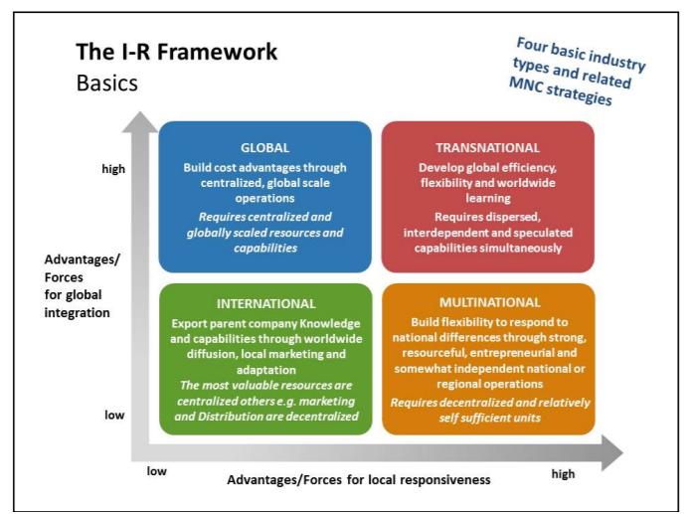
Incentive Strategy for speedy growth of Organisation
Why Incentives?
- Highly motivate employees for better productive work
- Reduce employee turnover rate
- Show more loyalty to the company
- More committed employees
Incentive Plan:
- All employees will be paid with the basic pay structure; incentives are given above the basic pay.
- Above a certain mandatory task to be performed on the working days, work target will be set for every job
- The work will be divided into different categories and every work will be certain weightage percentage.
- An employee will be able to draw proportionate amount of monetary incentive based on the percentage of work completed with respect to the points earned over the mandatory work per day.
Monetary Incentives in Ramalingam Foods may include- 1) Bonuses for surpassing the objectives as set by the management,2) Commission for achieving the sales target,3) Cash rewards
Non-Monetary Incentives in Ramalingam Foods may include- 1) Formal recognition/ awards for its high performing employees,2) Extra Holidays for achieving certain sales targets of its products as set by the management,3) Gifts, 4) Company cars for high ranked employees, who will be performing exceptionally well.

Training Plan
Why training?
Train your employees enough that your competitors will be willing to pay them double the amount you pay. Only eligible and efficient candidates will be hired for work, yet training is essential in an organisation for better productivity and to eliminate chaos during work. That too in a MNC like Ramalingam Foods now, to stick to the organisational policy and procedure and to bring in order in work training sees it’s at most importance. Training plan for manufacturing ready-to-cook food industry is below: -
- Skill-gap assessment will be done once in a semester
- If the employees are seen under skilled in any department, they will be immediately sent for specific training programs. Few of them are stated below
- Operations – 6 sigma certifications
- Marketing – Digital marketing, Customer Relationship Management, Branding
- Human Capital – Negotiating skills, SHRM, Soft skills…etc.
- A minimum of 10 candidates will be sent for training programs at a time
Essential Training Programs for International Business expansion
- Prosci Change management program
- Export-Import program

Management principles used:
1. Division of Work – When employees are specialized, output can increase because they become increasingly skilled and efficient.
2. Unity of Command – Employees should have only one direct supervisor.
3. Unity of Direction – Teams with the same objective should be working under the direction of one manager, using one plan. This will ensure that action is properly coordinated.
4. Remuneration – Employee satisfaction depends on fair remuneration for everyone. This includes financial and non-financial compensation.
5. Centralization – This principle refers to how close employees are to the decision-making process. It is important to aim for an appropriate balance.
6. Order – The workplace facilities must be clean, tidy and safe for employees. Everything should have its place.

